PHOTOGRAPHY CONTEST PORTAL
@CREATIVITY THINK (9483175986/7019689991)

ABSTRACT:
The Photography Contest Portal is a web-based platform designed to manage and streamline photography contests for clubs, schools, and marketers. It allows participants to upload entries, receive votes and comments, and track contest progress through interactive dashboards. Administrators can create, approve, and close contests, manage users, and analyze contest statistics in real time. Built using Django and Django Rest Framework for the backend and React with Redux and Dropzone for the frontend, the system provides a secure, scalable, and user-friendly environment for both participants and organizers, enhancing engagement and operational efficiency..

INTRODUCTION OF THE PROJECT:
Traditional photography contests often involve manual submission, offline voting, and cumbersome management, leading to inefficiencies and limited transparency. The Photography Contest Portal addresses these challenges by providing a centralized digital platform for submitting entries, tracking votes, enabling feedback, and analyzing contest outcomes. Users can participate seamlessly, while administrators maintain control over contest integrity, user management, and statistical insights. The system simplifies contest operations, increases participation, and ensures secure handling of all entries..

PROJECT OBJECTIVES:

• Provide a secure platform for uploading and submitting photography entries
• Enable participants to vote, comment, and track contest status
• Maintain contest statistics and analytics for user engagement
• Allow administrators to create, approve, and close contests
• Manage users, entries, and permissions efficiently
• Offer dashboards for monitoring votes, comments, and winners
• Ensure a scalable system capable of handling multiple contests simultaneously
• Generate reports and analytics for better decision-making

PROBLEM OF THE STATEMENT:
Manual management of photography contests is prone to errors, delays, and limited accessibility. Tracking votes, comments, and contest progress becomes challenging, while administrators face difficulties in moderating entries and managing users effectively. The Photography Contest Portal provides a centralized solution that digitizes the entire contest workflow, automates voting and feedback, ensures fair and transparent results, and equips administrators with analytics-driven insights..

MOTIVATION OF THE PROJECT:
• To provide a structured, automated platform for photography contests
• To enhance participant engagement through voting and commenting features
• To simplify contest management and entry approvals for administrators
• To maintain transparency and accuracy in contest results
• To enable analytics-driven insights for organizers and clubs
• To increase accessibility and participation from a wider audience
• To provide a secure and user-friendly environment for contests

BLOCK DAIGRAM OF PROJECT:

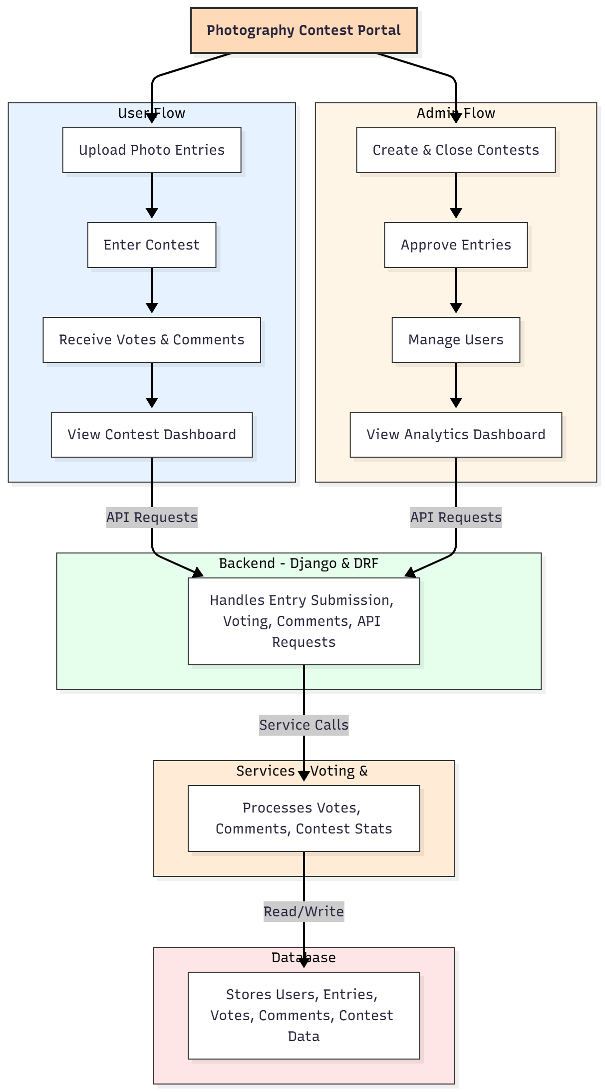

WORKING OF THE PROJECT:
Participants begin by uploading photos to enter contests. The system validates entries and stores them securely in the database. Users can vote on and comment on submissions while viewing real-time contest statistics via the dashboard. Administrators create contests, approve submissions, manage users, and monitor analytics. Voting and comment services process interactions, updating entries and dashboards dynamically. The backend ensures secure handling of submissions, votes, and user data, while the database maintains structured storage for all activities, enabling a transparent and efficient contest workflow..

SOFTWARE REQUIREMENT:
- Backend:
  - Python 3.x
  - Django
  - Django REST Framework
  - SQLite/PostgreSQL
- Frontend:
  - Node.js and npm
  - React.js
  - Axios
- Development Tools:
  - Visual Studio Code
  - Postman (for testing APIs)
  - Git/GitHub (for version control)
- Server/Deployment (Optional):
  - Gunicorn, Nginx, or Heroku/AWS for hosting

ADVANTAGES OF THE PROJECT:

• Automates contest management and participation
• Transparent voting and feedback system
• Real-time dashboards for participants and administrators
• Efficient handling of multiple contests simultaneously
• Reduces manual errors and administrative workload
• Secure storage of entries and votes
• Increases engagement through interactive features
• Analytics-driven decision-making for organizers

APPLICATIONS OF THE PROJECT:
• Photography clubs and communities
• Schools and educational institutions
• Marketing agencies and promotional events
• Online contests and competitions
• Corporate events and employee engagement programs

REFERENCES:

- Django REST Framework Documentation — Django Software Foundation. Django Documentation. Available: https://docs.djangoproject.com/
- Django REST Framework. DRF Documentation. Available: https://www.django-rest-framework.org/
- React. React Official Documentation. Available: https://reactjs.org/docs/getting-started.html
- Redux. Redux Documentation. Available: https://redux.js.org/introduction/getting-started
- PostgreSQL Global Development Group. PostgreSQL Documentation. Available: https://www.postgresql.org/docs/
- MySQL. MySQL Reference Manual. Available: https://dev.mysql.com/doc/
- Git. Git Documentation. Available: https://git-scm.com/doc
- Node.js. Node.js Documentation. Available: https://nodejs.org/en/docs/
- Axios. Axios Documentation. Available: https://axios-http.com/docs/intro
- Socket.io Documentation – https://socket.io/docs/

